Psalm 119:105

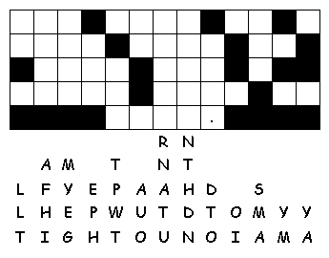

Use the above letters to fill in the verse.

